What is an API?

**Application Programming Interface (API)** is a software interface that allows two applications to interact with each other without any user intervention. API is a collection of software functions and procedures. In simple terms, API means a software code that can be accessed or executed. API is defined as a code that helps two different software’s to communicate and exchange data with each other.

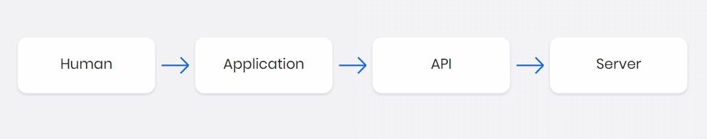

Fig 1: What is API

Working of an API

The application (such as a website or a mobile app) will make an API call for a set of data to display for the end user to consume. The request is made via the API that accesses the web server to retrieve the requested data, which is populated in the user interface.

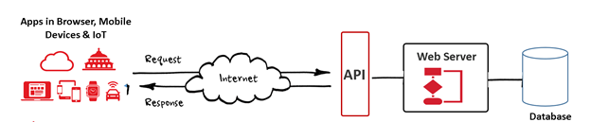

Fig: Working of an api

What is an Open API?

An Open API is an application programming interface (API) that enables third-party developers to build software applications and web services. These applications and services facilitate financial transparency and support financial institutions in finding new revenue models. Open API Specification is the format typically used to define restful APIs. Open API documents can be read by humans and machines, allowing for easily comprehendible APIs. Engineers use these APIs to design servers, source code, and complete contract testing.

Open APIs have three main characteristics:

* They are available for use by developers and other users with relatively few restrictions. Restrictions might include the necessity to register with the service providing the API.
* They are typically backed by [open data](https://en.wikipedia.org/wiki/Open_data). Open data is freely available for everyone to use and republish as they wish, without restrictions from copyright, patents or other mechanisms of control. An Open API may be free to use but the publisher may limit how the API data can be used.
* They are based on an [open standard](https://en.wikipedia.org/wiki/Open_standard).

The most common open API architectures fall into two categories: REST APIs and SOAP APIs.

SOAP and REST offer different methods to invoke a web service. [SOAP](https://www.techtarget.com/searchapparchitecture/definition/SOAP-Simple-Object-Access-Protocol)-based APIs typically use XML as a data exchange format, while RESTful APIs typically use JSON back and forth. Both approaches have supporters and opponents.

Examples of Open API

**SendGrid:** The Twilio-owned email infrastructure API stores its OpenAPI descriptions in a GitHub repo. Whenever it’s updated, its API reference is updated with the latest documentation for its API.

**US Patent and Trademark API:** Maintained by the OpenAPI community, this describes a real government API.

**GitHub:** The code collaboration tool [released its description](https://github.blog/2020-07-27-introducing-githubs-openapi-description/) with more than 600 operations. The GitHub API is extensive and mature, which makes this one good to study.